**Hybrid Attack**

* **Hybrid Wordlist + Mask (-a 6):**

In a hybrid attack using Hashcat with the Wordlist + Mask mode (-a 6), we combine a dictionary wordlist with a custom pattern to create potential passwords. This method allows us to modify dictionary words in specific ways.

Command: hashcat -m 0 -a 6 hashes.txt /usr/share/wordlists/rockyou.txt ?l?l?l

Step-by-Step Explanation

1. Choosing the Mode (-a 6):
   * The -a 6 option in Hashcat specifies the hybrid attack mode where the wordlist is used as the base, and the mask is applied to the end of each word.
2. Specifying the Hash Type (-m 0):
   * The -m 0 option specifies the hash type. In this case, 0 stands for MD5. Different hash types have different numbers.
3. Providing the Hash File (hashes.txt):
   * This is the file containing the hashes you want to crack. Each hash should be on a separate line.
4. Specifying the Wordlist (rockyou.txt):
   * The wordlist file contains a list of common passwords or words that will serve as the base for generating candidate passwords. For example, rockyou.txt is a popular wordlist.
5. Defining the Mask (?l?l?l):
   * The mask defines the pattern to be applied to each word in the wordlist. ?d represents a digit (0-9). So, using ?l?l?l in a hybrid attack with Hashcat, you are specifying a mask that appends three lowercase letters (a-z) to each word in the wordlist.



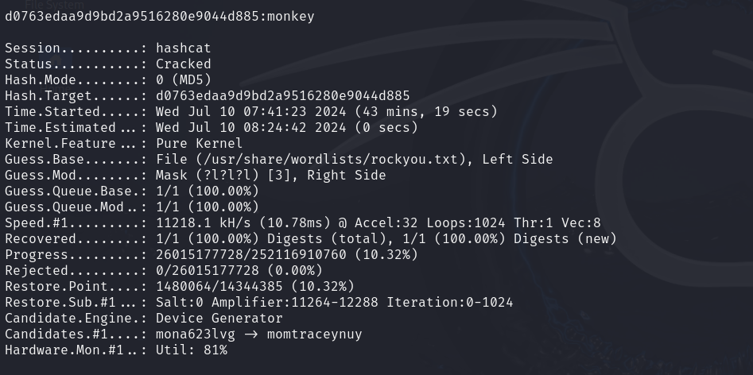

* **Combining Tools for Hybrid Attacks**
* Crunch + Hashcat: Generate a hybrid wordlist with Crunch and use it in Hashcat.

A hybrid attack that uses both Crunch and Hashcat combines wordlist generation with advanced password cracking techniques. This method involves two main steps:

1. Custom wordlist creation: Use Crunch to produce a tailored list of potential password bases. This allows you to specify parameters like length, character sets, and patterns.
2. Enhanced cracking with Hashcat: Apply the Crunch-generated wordlist in Hashcat, utilizing its mask feature. This enables you to modify and expand upon the base words systematically.

Step 1: Generate a Custom Wordlist with Crunch:

Command:crunch 4 4 -t @@,, > hybrid.txt

Breakdown:

* crunch: The command-line tool being used.
* 4 4: Minimum and maximum length of the passwords. Here, both are set to 4.
* -t @@,,: The pattern to generate the words.
  + @: Each @ will be replaced by a lowercase letter (a-z).
  + , : Each ? will be replaced by a uppercase letter (A-Z).
* > hybrid.txt: Redirects the output to a file named hybrid.txt.

Step 2: Perform the Hybrid Attack with Hashcat

Command: hashcat -m 0 -a 0 hashes.txt hybrid.txt

Breakdown:

* hashcat: The command-line tool being used for password cracking.
* -m 0: Specifies the hash type (MD5 in this case).
* -a 6: Specifies the attack mode (Wordlist + Mask).
* hashes.txt: The file containing the hashes to be cracked.
* hybrid.txt: The wordlist file generated by Crunch.

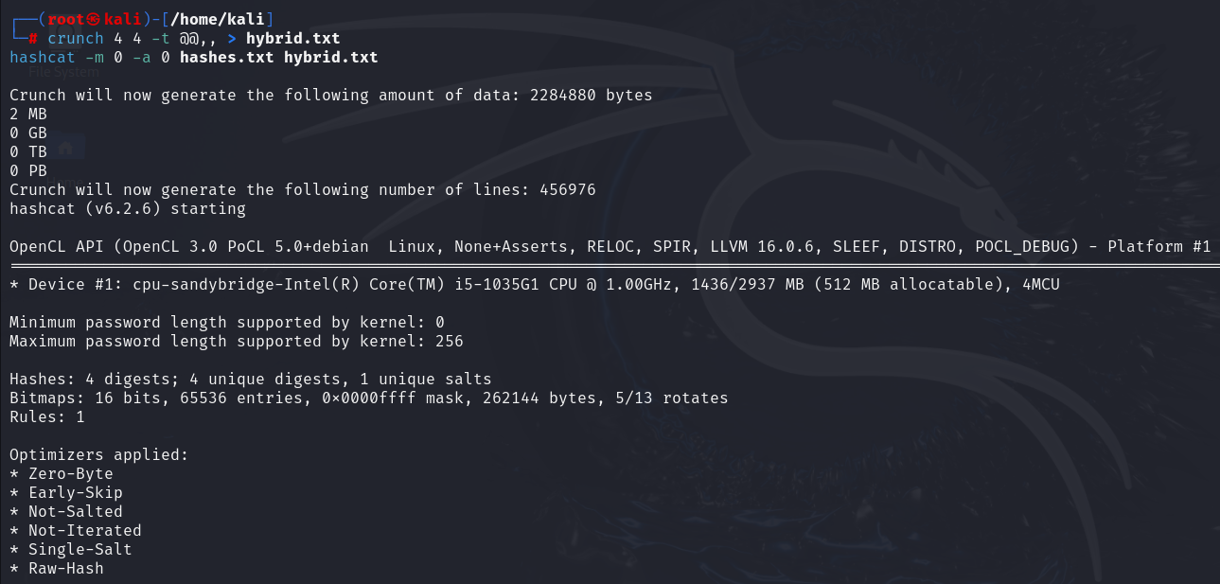

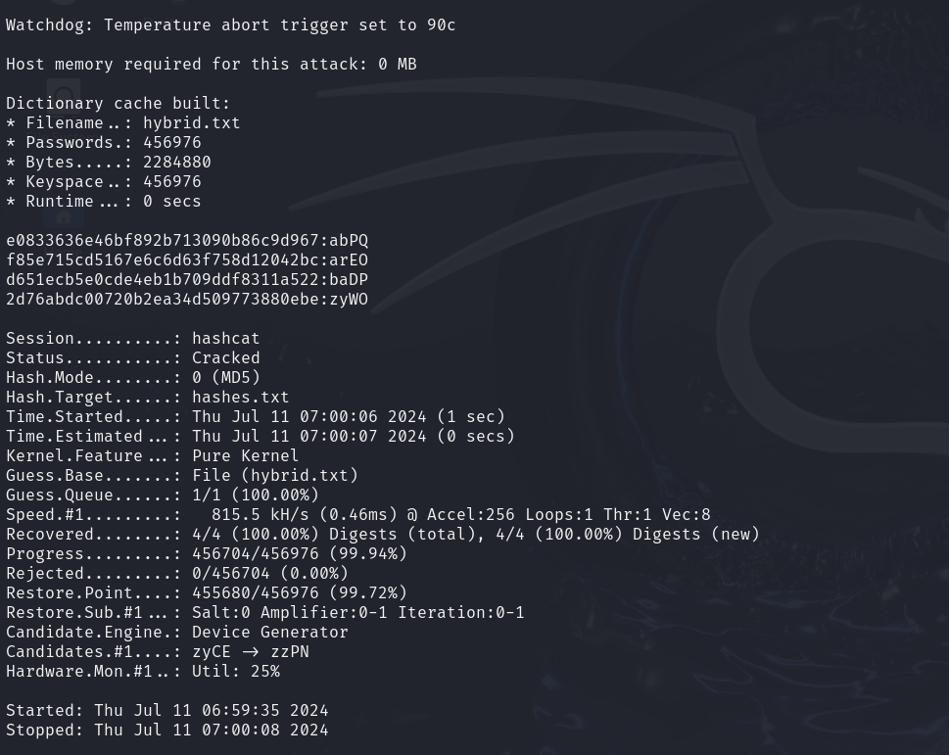

Conclusion:

Hybrid password cracking methods offer a balanced approach, merging the strengths of dictionary-based techniques with comprehensive brute-force strategies. This combination allows for more efficient and effective password analysis.

By leveraging specialized tools, cybersecurity professionals can:

1. Generate targeted wordlists

2. Apply systematic modifications to these base words

3. Test a wide range of potential passwords efficiently

The benefits of this approach include:

- Improved success rates in password recovery

- Deeper insights into common password patterns

- Ability to identify and address security vulnerabilities

Ultimately, hybrid attacks serve as a valuable tool for assessing and enhancing password policies, helping organizations strengthen their overall security posture. They provide a practical way to simulate real-world threats and develop more robust defense strategies.